System and Software Architecture Description (SSAD)

Spherical Modeling Tool

Team 13

Minsuk Heo, Prototyper

Lyle Franklin, Project Manager

Mehmet Sezer, Requirements Engineer

Oziel De Oliveira Carneiro, Feasibility Analyst

Nikita Vlasenko, OCD

Guoxiong Xie, Life Cycle Planner

Sait IIhaner, IIV&V

Table of Contents

A.1 Introduction.............................................................................................................................3
A.1.1 Purpose of the SSAD.....................................................................................................................3
A.1.2 Status of the SSAD...........................................................................................................3
A.2 System Analysis......................................................................................................................4
A.2.1 System Analysis Overview................................................................................................4
A.2.1.1 System Context..............................................................................................................4
A.2.1.2 Artifacts and Information................................................................................................4
A.2.1.3 Behavior.........................................................................................................................6
Use Case Descriptions........................................................................................................7
A.2.2 System Analysis Rationale..............................................................................................30
A.3 System Design......................................................................................................................32
A.3.1 Design Overview.............................................................................................................32
A.3.1.1 System Structure.........................................................................................................32
A.3.1.2 Design Classes............................................................................................................34
A.3.1.3 Process Realization.....................................................................................................34
A.3.2 Design Rationale.............................................................................................................35
A.5 Architectural Styles, Patterns, and Frameworks...................................................................37

Version History

Date | Author | Version | Changes made | Rationale
12/04/13 | LF | 1.0 | - N/A | - Initial Draft of the SSAD for Team 13

A.1 Introduction

A.1.1 Purpose of the SSAD

This document is intended to give an architectural specification of the proposed Spherical Modeling Tool system. The following sections provide both a high-level overview and implementation-level details of the proposed system. Based on our team's current understanding, a system built to this specification will satisfy the client's needs.

A.1.2 Status of the SSAD

This document represents the current architectural body of knowledge our team possesses as of the end of the Fall 2013 semester. This document will be updated throughout the Spring 2014 semester to reflect new architectural knowledge gained during the implementation of this system.

A.2 System Analysis

A.2.1 System Analysis Overview

The Spherical Modeling Tool (SMT) is a data visualization model that uses the shape of a sphere to provide a holistic evaluation of the condition of dynamic systems.
Our mission is to improve productivity, communication, awareness and understanding in a wide variety of areas, including education, healthcare, business, government, and community development by creating a system for information visualization and holistic, integrative thinking.

A.2.1.1 System Context
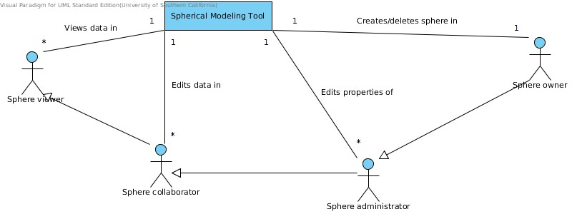Figure 1: System Context Diagram
Actor | Description | Responsibilities
Sphere owner | Owner of the given sphere | Creator of the sphere, can delete the sphere
Sphere administrator | One of the admins for the given sphere | Can edit or add questions, change title, and grant permissions to other users
Sphere collaborator | A user who was invited to contribute data | Can answer questions for the given sphere
Sphere viewer | A user who was invited to view data | Can view data visualizations and data contributed by other users

A.2.1.2 Artifacts and Information

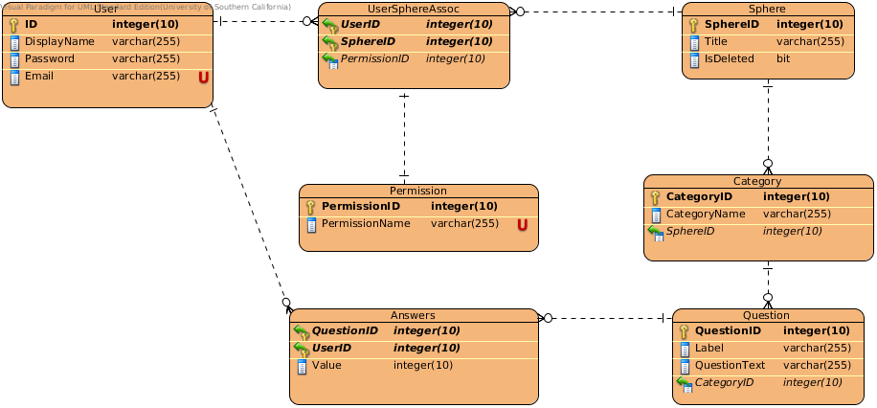Figure 2: Artifacts & Info. Diagram

Artifact | Purpose
User | Keeps track of account information
UserSphereAssoc | Maintains records of which users have access to which spheres with corresponding levels of permission
Permission | A static table of system permissions (Owner, Admin, etc.)
Sphere | Records of high-level sphere data (e.g. Title)
Category | Belongs to a given sphere; a container for grouping similar questions
Question | A question belonging to a given category
Answer | Keeps track of a user's answer to a given question

A.2.1.3 Behavior
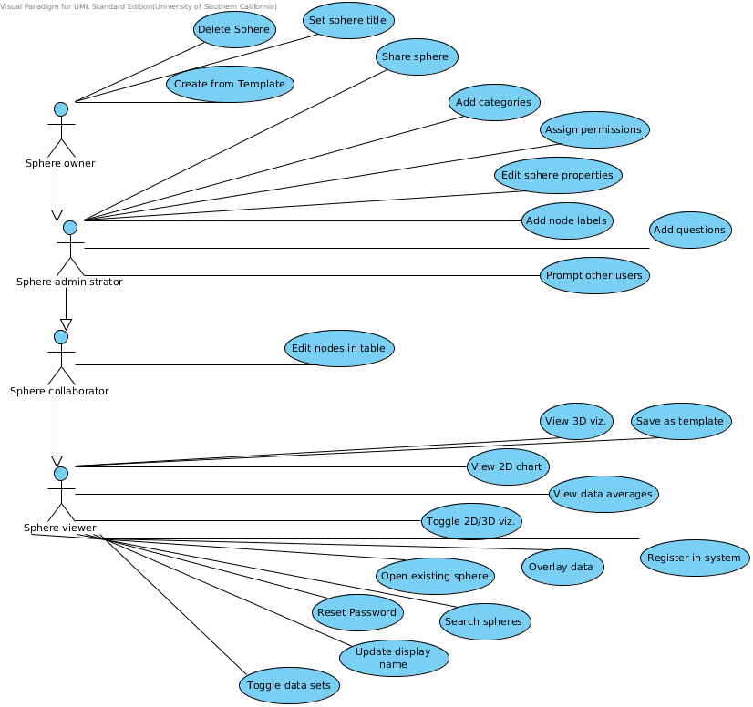Figure 3: Use Case Diagram

Use Case Descriptions
Create from Template
Use Case ID | UC28
Brief Description | As a user I can create a sphere from a template.
Actor | Sphere owner
Preconditions | User has access to at least one template.
Post-conditions | A sphere is added to database with questions and categories copied from an existing template, or the create template button is disabled.
Flow of Events
   | Actor Input | System Response
  1 | User clicks Create from Template.
  2 |  | Queries database for available templates.
  3 |  | Display a list of templates.
  4 | Clicks a template.
  5 |  | Creates a new sphere in database with copied categories and questions.
  6 |  | Displays the Edit Sphere page.
Alt. Flow
   | Actor Input | System Response
  1 | User has no templates available.
  2 |  | Disables Create from template button.

Toggle data sets
Use Case ID | UC27
Brief Description | As a user I can select which sets of data show up in the 2D/3D visualizations.\
Actor | Sphere viewer
Preconditions | User is on one of the visualization pages.
Post-conditions | The data set being displayed is changed in 2D or 3D.
Flow of Events
   | Actor Input | System Response
  1 | Clicks Filter Data on 2D chart page.
  2 |  | Queries database for users that have answered questions in this sphere.
  3 |  | Displays list of users with a checkbox next to each.
  4 | Selects one to many users.
  5 |  | Updates the chart with only the data for checked users.
Alt. Flow
   | Actor Input | System Response
  1 | Clicks Filter Data on 3D chart page.
  2 |  | Queries database for users that have answered questions in this sphere.
  3 |  | Displays list of users with a radio button next to each.
  4 | Select one user.
  5 |  | Updates 3D sphere to show data for selected user.

Search spheres
Use Case ID | UC26
Brief Description | As a user I can search my spheres by name and owner.\
Actor | Sphere viewer
Preconditions | User has access to at least one sphere. User is on Open Sphere page.
Post-conditions | User is presented with a list of spheres matching search, or No Match Found is displayed.
Flow of Events
   | Actor Input | System Response
  1 | User enters a search string.
  2 |  | Searches database for sphere title or owner that matches search string.
  3 |  | Builds a list of matches and displays them to user.
Alt. Flow
   | Actor Input | System Response
  1 | User enters a search string.
  2 |  | Searches database, but finds no matches.
  3 |  | Displays a No Matches Found message to user.

Delete sphere
Use Case ID | UC25
Brief Description | As a sphere owner I can delete my spheres.\
Actor | Sphere owner
Preconditions | User has Sphere Owner permission. User is on Sphere Edit page.
Post-conditions | Sphere is logically deleted from database.
Flow of Events
   | Actor Input | System Response
  1 | User clicks Delete Sphere.
  2 |  | Display confirmation prompt.
  3 | Clicks Yes.
  4 |  | Marks sphere as deleted in database.
  5 |  | Redirects user to Home page.
Alt. Flow
   | Actor Input | System Response
  1

Update display name
Use Case ID | UC24
Brief Description | As a user I can update my display name.\
Actor | Sphere viewer
Preconditions | User has already create an account. User is on Manage Account page.
Post-conditions | Database is updated with new display name, or error message is displayed.
Flow of Events
   | Actor Input | System Response
  1 | Enters new name and clicks submit.
  2 |  | Updates database with new display.
  3 |  | Display success message to user.
Alt. Flow
   | Actor Input | System Response
  1 | Enters blank name and clicks submit.
  2 |  | Display error message to user.

Reset password
Use Case ID | UC23
Brief Description | As a user I can reset my password.\
Actor | Sphere viewer
Preconditions | User has already created account.
Post-conditions | Database is updated with new password, or reset password link expires.
Flow of Events
   | Actor Input | System Response
  1 | User clicks Forgot Password link.
  2 |  | Prompts for email address.
  3 | Enters Email and clicks submit.
  4 |  | Generates security token.
  5 |  | Sends email to user containing reset link and security token.
  6 |  | Displays email send message to user.
  7 | Opens email and follows link.
  8 |  | Checks security token validity.
  9 |  | Prompts user to enter new password.
  10 | Enters new password.
  11 |  | Stores new password in database.
Alt. Flow
   | Actor Input | System Response
  1 | User clicks reset link after already resetting password.
  2 |  | System checks token validity.
  3 |  | System responses that link is no longer valid.

Register in system
Use Case ID | UC22
Brief Description | As a user I can register so that I can create a sphere. Requires email, name, password.
Actor | Sphere viewer
Preconditions | User in not registered.
Post-conditions | User is registered, or a form validation error is diplayed.
Flow of Events
   | Actor Input | System Response
  1 | User clicks on the “Register” button on the Spherical Modeling Tool page.
  2 |  | “Registration” page is displayed.
  3 | Users fills the “User Name”, “Email Address”, “Create Password” and “Confirm Password” fields and clicks on the submit button.
  4 |  | If the passwords match (with more than 5 characters) and if it does not exist a user with same user name in the database, a new user data including user name with email address and password is added to the database.
  5 |  | “Open or Create Sphere” page is displayed.
Alt. Flow
   | Actor Input | System Response
  1 | Users fills the “User Name”, “Email Address”, “Create Password” and “Confirm Password” fields and clicks on the submit button.
  2 |  | If there exists a mismatch between the passwords, “Registration” page is displayed with the title of “Please Enter The Password again with more than 5 characters or numbers”.
  3 |  | If there exists a user with same user name in the database, “Registration” page is displayed with the title of “Someone already has that username. Please try another”.

Add node labels
Use Case ID | UC21
Brief Description | As a user I can enter node labels. Weight -> Is my weight where I want it to be? -> Physical
Actor | Sphere administrator
Preconditions | User is logged in. User has already entered questions for the nodes.
Post-conditions | Nodes are labeled.
Flow of Events
   | Actor Input | System Response
  1 | User clicks on the submit button in the “Start a new Sphere” page.
  2 |  | “Create Sectors and Nodes” page is displayed.
  3 | User enters the node names in the “Node name” fields.
  4 |  | The node names for the sphere is updated on the database.
Alt. Flow
   | Actor Input | System Response
  1 | User clicks on the “Add Node” button.
  2 |  | A new “Node Name” field is added to the “Create Sectors and Nodes” page.
  3 | User enters the node names in the “Node name” fields.
  4 |  | The node names for the sphere is updated on the database.

Add categories
Use Case ID | UC20
Brief Description | As a user I can enter sectors (categories) for each node. This includes different colored nodes for each sector. This doesn't include rendering effort.
Actor | Sphere administrator
Preconditions | User is logged in.
Post-conditions | Nodes are categorized (colored).
Flow of Events
   | Actor Input | System Response
  1 | User clicks on the submit button in the “Start a new Sphere” page.
  2 |  | “Create Sectors and Nodes” page is displayed.
  3 | User enters the question(s) (and node(s)) in the “Question” field(s).
  4 |  | The question(s) for the sphere is updated on the database.
  5 | User enters the Sector Name in the “Sector Label Here” field.
  6 |  | The Sector Label of the questions of the sphere is updated on the database.
Alt. Flow
   | Actor Input | System Response
  1 | User clicks on the “Add Sector” button to add more sectors.
  2 |  | A new “Sector Label Field” is added to the “Create Sectors and Nodes” page.
  3 | User enters the Sector Name in the “Sector Label Here” field.
  4 |  | The Sector Label of the questions of the sphere is updated on the database.

Add questions
Use Case ID | UC19
Brief Description | As a user I can generate questions for each node.
Actor | Sphere administrator
Preconditions | User is logged in.
Post-conditions | The questions are added to the database.
Flow of Events
   | Actor Input | System Response
  1 | User clicks on the submit button in the “Start a new Sphere” page.
  2 |  | “Create Sectors and Nodes” page is displayed.
  3 | User enters the questions in the fields for nodes.
  4 |  | The questions for the sphere is updated on the database.
Alt. Flow
   | Actor Input | System Response
  1 | User clicks on the “Add Node” button to add more nodes for questions.
  2 |  | New “Question” and “Node Name” fields are added to the “Create Sectors and Nodes” page.
  3 | User enters the questions in the fields for nodes.
  4 |  | The questions for the sphere is updated on the database.

View 3D viz.
Use Case ID | UC18
Brief Description | As a user I see the data visualize in a 3D sphere. This includes grouping the nodes by category.
Actor | Sphere viewer
Preconditions | User is logged in. User has predefined sphere(s) in database. User has already answered questions.
Post-conditions | User is shown 3D visualization.
Flow of Events
   | Actor Input | System Response
  1 | User clicks on the “3D Render View” in the “2D Chart view” page.
  2 |  | The sphere data is taken from the database and according to the 3D visualization algorithm, the sphere is displayed in the “3D Sphere View” page.
Alt. Flow
   | Actor Input | System Response
  1

Set sphere title
Use Case ID | UC17
Brief Description | As a user I can title a sphere. No restrictions on duplicate names. Spheres require a unique id.
Actor | Sphere owner
Preconditions | User is logged in.
Post-conditions | A sphere has a title.
Flow of Events
   | Actor Input | System Response
  1 | User clicks on the “Start a new Sphere” button.
  2 |  | “Open or Create Sphere” page is displayed.
  3 | User writes the title in “Title Your Sphere” field and clicks on the submit button.
  4 |  | The title of the sphere is updated in the database.
  5 |  | “Create Sectors and Nodes” page is displayed.
Alt. Flow
   | Actor Input | System Response
  1 | -

Save as template
Use Case ID | UC14
Brief Description | As a user I can save a sphere as a template. All questions and nodes labels exist, but no values.
Actor | Sphere viewer
Preconditions | User is logged in.
Post-conditions | A sphere template without values is created by a user.
Flow of Events
   | Actor Input | System Response
  1 | Clicks on the “Open a Sphere Template”
  2 |  | An empty list of questions and nodes displayed.
  3 | Enters the questions and nodes.
  4 | Clicks "Save Template"
  5 |  | Saves template to database.
Alt. Flow
   | Actor Input | System Response
  1 | -

Open existing sphere
Use Case ID | UC13
Brief Description | As a user I can open an existing sphere project. This include loading a sphere from the database.\
Actor | Sphere viewer
Preconditions | User is logged in. Use has already created a sphere.
Post-conditions | User successfully opens a sphere, or an empty list is displayed.
Flow of Events
   | Actor Input | System Response
  1 | Clicks "Open a Saved Sphere"
  2 |  | Requests sphere list of the user from the database.
  3 |  | Displays list of saved spheres.
  4 | Selects one sphere from the list.
  5 |  | Displays 2D view of selected sphere.
Alt. Flow
   | Actor Input | System Response
  1 | Clicks on the “Open a saved sphere” button.
  2 |  | Requests sphere list of the user from the database.
  3 |  | If there is no saved spheres in the database, the empty list is displayed.

Overlay data
Use Case ID | UC12
Brief Description | As a user I can overlay data from different users so that I can compare different shapes (w/different colors). This only includes the 2D rendering.
Actor | Sphere viewer
Preconditions | At least one user has entered data for given sphere. User has permission to view sphere. User is on 2D chart page.
Post-conditions | User is shown multiple data sets overlaid.
Flow of Events
   | Actor Input | System Response
  1 | Clicks Compare button.
  2 |  | Displays list of users that have entered data for this sphere.
  3 | Does not specifically select a subset of users.
  4 |  | Renders a different data set for each user, overlaid on 2D chart.
Alt. Flow
   | Actor Input | System Response
  1 | Selects a subset of users that have entered data.
  2 |  | Renders data for only selected users, overlaid on 2D chart.

Edit sphere properties
Use Case ID | UC11
Brief Description | As a user I can edit/add/remove nodes (questions), sectors (categories), and sphere title (with admin permission). Assume sphere creation functions already exist.
Actor | Sphere administrator
Preconditions | User has already created sphere. User has access to modify sphere. User is on sphere edit page.
Post-conditions | DB is updated with new sphere properties, or an error message is displayed.
Flow of Events
   | Actor Input | System Response
  1 | Clicks Edit sphere.
  2 |  | Displays sphere properties in editable table.
  3 | Changes values in table.
  4 | Clicks Update.
  5 |  | Validates input.
  6 |  | Updates DB with new properties.
  7 |  | Display success message to user.
Alt. Flow
   | Actor Input | System Response
  1 | Enters invalid values in table.
  2 |  | Displays error message to user.
  3 |  | Does not update DB with new properties.

View data averages
Use Case ID | UC10
Brief Description | As a user I can view the average of all (or subset) of selected user data in a single system. This does not include collaborative editing features. This does not include rendering the overlay.
Actor | Sphere viewer
Preconditions | At least one user has entered data for this sphere. User has access to view sphere.
Post-conditions | User is shown data averages.
Flow of Events
   | Actor Input | System Response
  1 | User is on sphere data page.
  2 |  | Display some data for each user that sphere is shared with.
  3 | User does not specifically select any subset of users.
  4 |  | Computes average of all users in sphere.
  5 |  | Displays values to user.
Alt. Flow
   | Actor Input | System Response
  1 | Selects a subset of users in sphere.
  2 |  | Computes average data for given subset.
  3 |  | Displays data to user.

Assign Permissions
Use Case ID | UC09
Brief Description | As a user I can assign permissions to other registered users. This includes defining (hardcoded) user roles. This doesn't include how those permissions are used/enforced.
Actor | Sphere administrator
Preconditions | User has already shared sphere with other users.
Post-conditions | Other user is given a different system permission.
Flow of Events
   | Actor Input | System Response
  1 | Clicks Share button.
  2 |  | Displays list of users with access to sphere. Each user has permission dropdown
  3 | Changes permission for one or more users.
  4 | Clicks Update button.
  5 |  | Updates DB with new permission info.
  6 |  | Display success message to user.
Alt. Flow
   | Actor Input | System Response
  1 | Clicks X button next to previously shared user.
  2 |  | Removes permission from user in database.
  3 |  | Deletes user response data from sphere if the user had answered questions.
  4 |  | Display Success Message.

Toggle 2D/3D viz.
Use Case ID | UC08
Brief Description | As a user I can toggle between 2D and 3D visualizations. This task only concerns switching between views, not implementing those views.
Actor | Sphere viewer
Preconditions | User is on 2D or 3D page. User has access to view sphere.
Post-conditions | User is shown the 2D visualization, or the 3D visualization.
Flow of Events
   | Actor Input | System Response
  1 | User is on 2D page.
  2 | Clicks 3D button.
  3 |  | Displays 3D visualization page.
Alt. Flow
   | Actor Input | System Response
  1 | User is on 3D page.
  2 | Clicks 2D button.
  3 |  | Displays 2D visualization page.

Prompt other users
Use Case ID | UC06
Brief Description | As a user I can prompt other users to enter data (notification through app and email).
Actor | Sphere administrator
Preconditions | First user has already told system to Share sphere with second user. Both users have accounts in the system.
Post-conditions | Second users receives email and in-app notification.
Flow of Events
   | Actor Input | System Response
  1 | Users tells system to share sphere with another user.
  2 |  | Sends email notification to second user.
  3 |  | Adds notification record in DB.
  4 | Second user logs into system.
  5 |  | Displays in-app notification to user.
  6 | User clicks notification.
  7 |  | Redirects to sphere edit page.
Alt. Flow
   | Actor Input | System Response
  1 | Second user logs into system.
  2 |  | Displays in-app notification to user.
  3 | User does not click notification.
  4 | User logs out.
  5 |  | Logs out user.
  6 | User logs back in.
  7 |  | Logs in user.
  8 |  | Displays notification again.

Share sphere
Use Case ID | UC05
Brief Description | As a user I can share a sphere with another user. This includes allowing another user to view your sphere and edit data (based on permissions).
Actor | Sphere administrator
Preconditions | User has created a sphere. User knows email address of second user. Second user has already created an account in the system.
Post-conditions | Second user can view/edit shared sphere, or an error message is displayed.
Flow of Events
   | Actor Input | System Response
  1 | First user clicks Share.
  2 |  | Displays list of users that sphere is already shared with.
  3 | Enters email of new user.
  4 | Clicks Add user.
  5 |  | Adds association in DB.
  6 |  | Sends notification to second user.
  7 |  | Displays success message to first user.
Alt. Flow
   | Actor Input | System Response
  1 | Enters email of user not in system.
  2 |  | Displays error message to first user.

Edit nodes in table
Use Case ID | UC03
Brief Description | As a user I can edit data in table format (editing node values).
Actor | Sphere collaborator
Preconditions | User is on sphere edit page. User has permission to edit sphere.
Post-conditions | DB is updated with new values, or Update button is disabled.
Flow of Events
   | Actor Input | System Response
  1 | Changes values of one or more nodes.
  2 | Clicks Update.
  3 |  | Updates DB with new values.
  4 |  | Redirects to sphere overview.
Alt. Flow
   | Actor Input | System Response
  1 | Changes no values.
  2 | Clicks Update.
  3 |  | Button is grayed out until values are changed. DB is not updated.

View 2D chart
Use Case ID | UC01
Brief Description | As a user I can visualize the data in a 2D chart. This includes grouping the nodes into categories.
Actor | Sphere viewer
Preconditions | User has logged in, user is on sphere list page. User has already answered questions.
Post-conditions | User is presented with a 2D chart, or an error message is displayed.
Flow of Events
   | Actor Input | System Response
  1 | Selects a sphere from a list of accessible spheres
  2 |  | Queries server for latest data
  3 |  | Renders 2D polar chart using data from server
Alt. Flow
   | Actor Input | System Response
  1 | Selects a sphere that has no associated data
  2 |  | Queries server for data
  3 |  | Display textual message to user indicating sphere has no data

A.2.2 System Analysis Rationale

Some aspects of the system described thus far may be misunderstood. Here are several extended explanations of features that could be misinterpreted:
- User permission levels (Owner, admin, collaborator, viewer) described previously are with respect to a given sphere. For example, Tom could be the Owner of the Health Sphere, a Viewer of the Community Sphere, and have no access to the Project Sphere. Any user can create any number of spheres, but that user must be granted permission to access another user's sphere(s).
- When a user is added as a Collaborator to a sphere, the user must answer the sphere's questions before viewing any data.
- Anyone with access to the sphere can see data from all the users that have answered questions for that sphere.
- Questions must be answerable with an integer value from 1 to 9. For example, “How happy are you with your weight?”.

A.3 System Design

A.3.1 Design Overview

A.3.1.1 System Structure

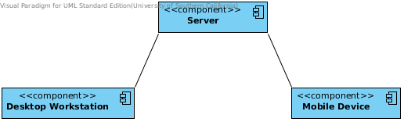Figure 4: Hardware Component Diagram

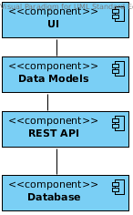Figure 5: Software Component Diagram

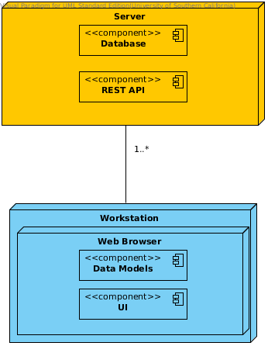Figure 6: Deployment Diagram

A.3.1.2 Design Classes
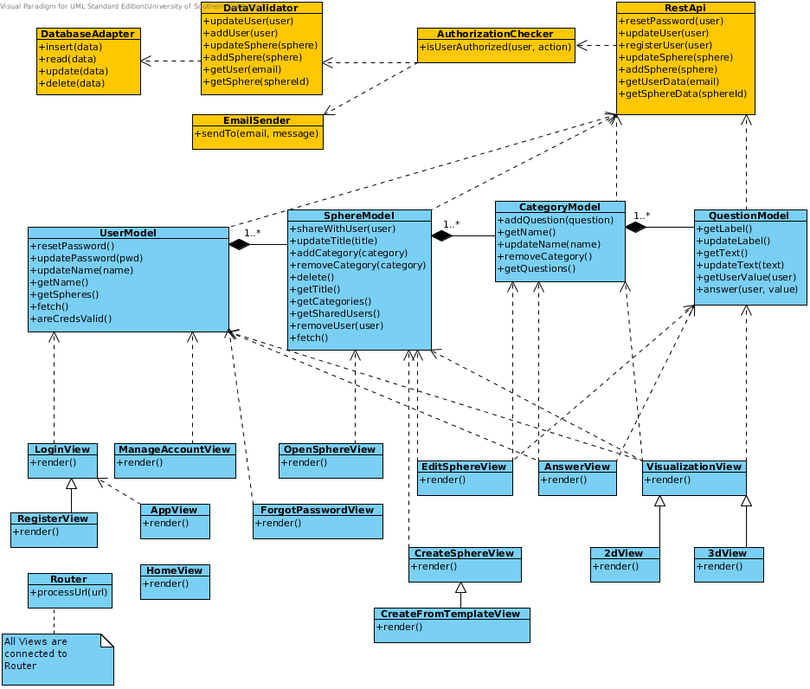Figure 7: Class Diagram

A.3.1.3 Process Realization

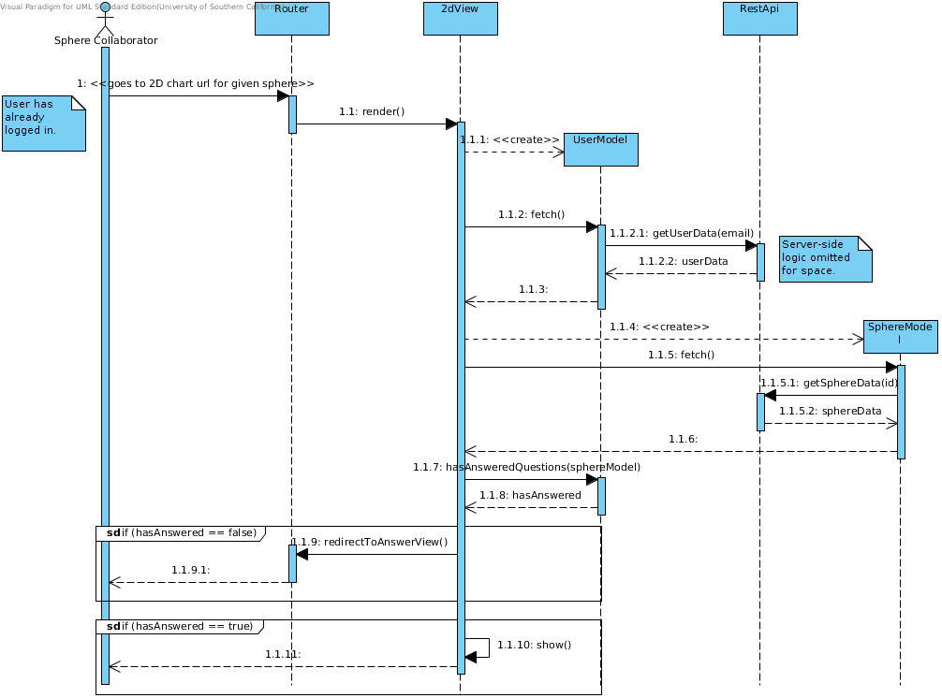Figure 8: Collaborator Sequence Diagram

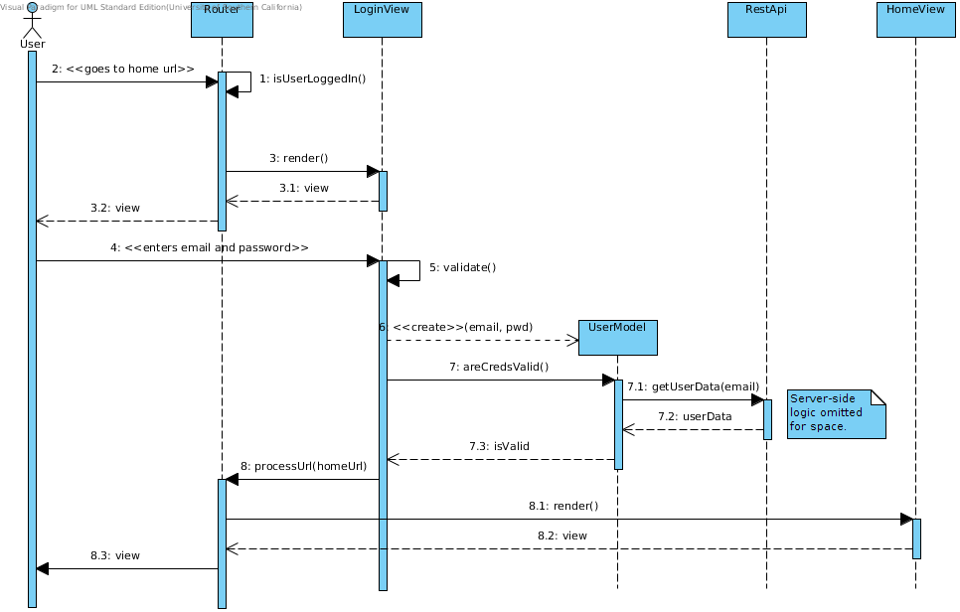Figure 9: Login Sequence Diagram

A.3.2 Design Rationale

The Hardware Component, Software Component, and Deployment Diagrams show that this system is a web-application which utilizes a client-server architecture. The Hardware Component Diagram also shows this application will be useable on both desktop and mobile devices.
The Class Diagram shows an implementation-level view of the system. In order to achieve the speed and fluidity of a native application, most of the logic will take place client-side using JavaScript. The Class Diagram shows server-side components in orange, and the client-side components in blue.
The server-side will be a lightweight REST API which is primarily concerned with data validation and storage, as well as user permissions.
The client-side will follow a Model-View pattern favored by many JavaScript frameworks. A variety of models will be constructed by fetching data from the server, and dynamic Views will be rendered using these Models. As indicated by a note in the diagram, a Router component will map a given URL to the correct view. User input will update these Models and the changes will propogate back to the server.
The sequence diagrams detail two non-obvious use cases in our system. The first describes a Sphere Collaborator trying to visit the 2D Chart page. The system checks whether the user has already answered questions for the given sphere. If the user has answered the questions, the system will display the 2D chart page, else the user is redirected to the Answer page. The second sequence diagram describes the Login use case. The system validates the user's credentials server-side and only displays the requested page if the credentials match.

A.5 Architectural Styles, Patterns, and Frameworks

Name | Description | Benefits, Limitations
Node.js | Server-side JavaScript framework used to build event-based web applications | Benefits:  - Easy to setup and deploy  - Application lends itself to event-based style  - Native mapping to/from JSON data (Everything is JavaScript)  - Free  Limitations:  - Relatively new technology  - Team members not experienced with Node.js
Backbone.js | Client-side JavaScript Model-View framework | Benefits:  - Gives structure to client-side code  - Client-side code can switch views immediately without a round trip to server  - Several team members have experience with Backbone.js  - Free  Limitations:  - It could be argued that Angular.js is becoming a more popular option  - Moderate learning curve for team members without experience
MongoDB | A popular NoSQL database that supports documents in a JSON format | Benefits:  - JSON format requires minimal data mapping to/from JavaScript  - Integrates well with Node.js  - Dynamic schema is accomidating of changes in data structure  - Well-support by many hosting services  - Free  Limitations:  - Team members lack experience in this technology  - We may discover the data lends itself better to a relational database

